1. **How to Add Libraries?**

What are Libraries ?

Libraries are a collection of code that drive sensors,displays and modules, etc.

There are hundreds of additional libraries available on the Internet for download.

We will introduce the most simple way to add libraries .

Step 1：After downloading the Arduino IDE, you can right-click the icon of Arduino IDE.

Find the option "Open file location" shown as below:

[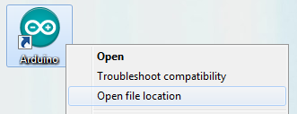](http://wiki.keyestudio.com/index.php/File:Libraries_1.png)

Step 2: Enter libraries folder of Arduino, as shown below;

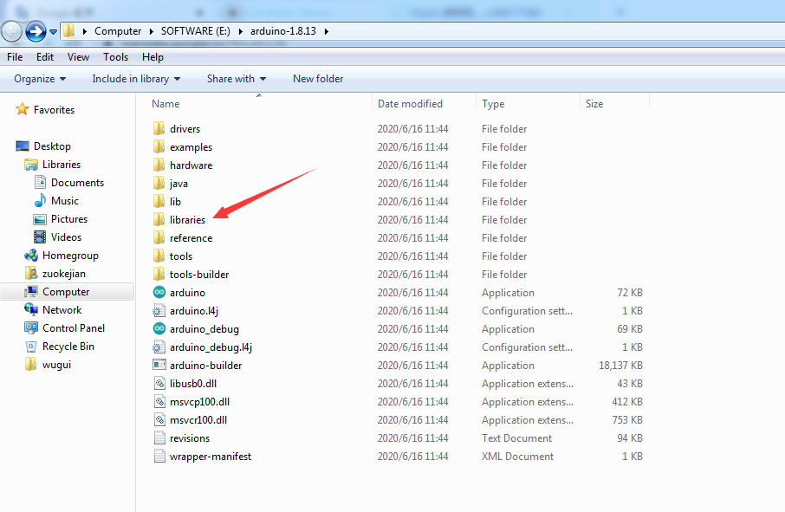

Step 3：Next, search the“libraries”of STEM kit(seen in the link: [https://fs.keyestudio.com/KS0506),](https://fs.keyestudio.com/KS0085),) as shown below:

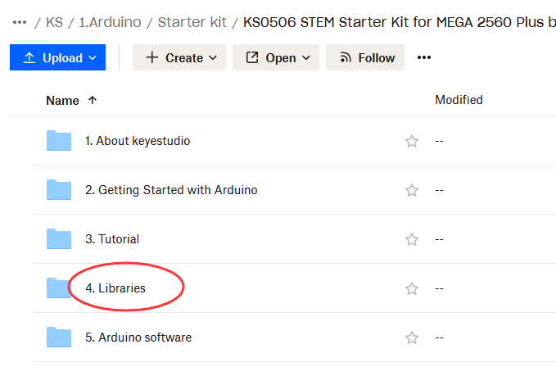

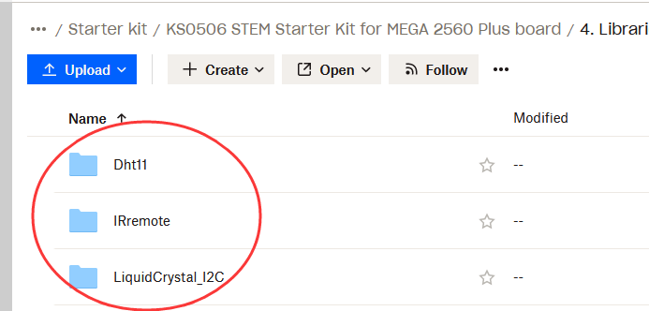

You just need to replicate and paste above libraries into the libraries folder of Arduino IDE.

Then, the libraries of home smart are successfully installed, as shown below:

